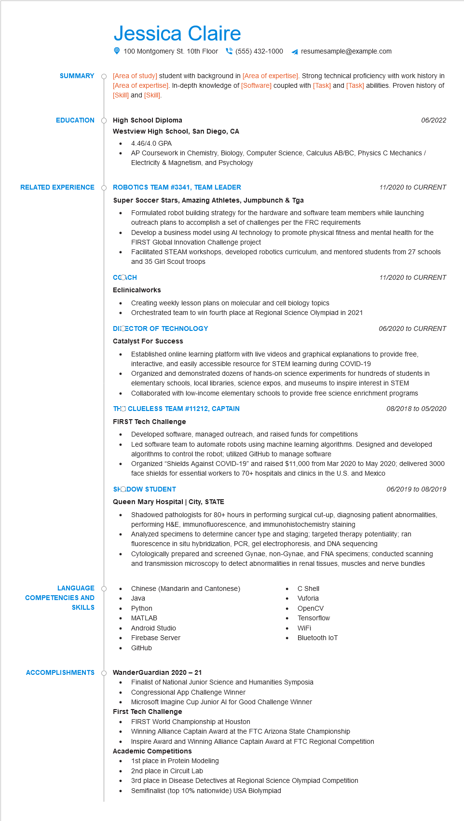
SUMMARY
EDUCATION
Jessica Claire
100 Montgomery St. 10th Floor (555) 432-1000
resumesample@example.com
[Area of study] student with background in [Area of expertise]. Strong technical proficiency with work history in [Area of expertise]. In-depth knowledge of [Software] coupled with [Task] and [Task] abilities. Proven history of [Skill] and [Skill].
High School Diploma
Westview High School, San Diego, CA
•
4.46/4.0 GPA
06/2022
AP Coursework in Chemistry, Biology, Computer Science, Calculus AB/BC, Physics C Mechanics/ Electricity & Magnetism, and Psychology
RELATED EXPERIENCE
Ó ROBOTICS TEAM #3341, TEAM LEADER
Super Soccer Stars, Amazing Athletes, Jumpbunch & Tga
11/2020 to CURRENT
LANGUAGE O
COMPETENCIES AND
SKILLS
•
Formulated robot building strategy for the hardware and software team members while launching outreach plans to accomplish a set of challenges per the FRC requirements
Develop a business model using Al technology to promote physical fitness and mental health for the FIRST Global Innovation Challenge project
Facilitated STEAM workshops, developed robotics curriculum, and mentored students from 27 schools and 35 Girl Scout troops
COOCH
Eclinicalworks
• Creating weekly lesson plans on molecular and cell biology topics
Orchestrated team to win fourth place at Regional Science Olympiad in 2021
DICECTOR OF TECHNOLOGY
Catalyst For Success
11/2020 to CURRENT
06/2020 to CURRENT
Established online learning platform with live videos and graphical explanations to provide free, interactive, and easily accessible resource for STEM learning during COVID-19 Organized and demonstrated dozens of hands-on science experiments for hundreds of students in elementary schools, local libraries, science expos, and museums to inspire interest in STEM Collaborated with low-income elementary schools to provide free science enrichment programs
THO CLUELESS TEAM #11212, CAPTAIN
FIRST Tech Challenge
•
Developed software, managed outreach, and raised funds for competitions
08/2018 to 05/2020
Led software team to automate robots using machine learning algorithms. Designed and developed algorithms to control the robot; utilized GitHub to manage software
Organized "Shields Against COVID-19" and raised $11,000 from Mar 2020 to May 2020; delivered 3000 face shields for essential workers to 70+ hospitals and clinics in the U.S. and Mexico
SHODOW STUDENT
Queen Mary Hospital | City, STATE
06/2019 to 08/2019
Shadowed pathologists for 80+ hours in performing surgical cut-up, diagnosing patient abnormalities, performing H&E, immunofluorescence, and immunohistochemistry staining
Analyzed specimens to determine cancer type and staging; targeted therapy potentiality; ran fluorescence in situ hybridization, PCR, gel electrophoresis, and DNA sequencing
Cytologically prepared and screened Gynae, non-Gynae, and FNA specimens, conducted scanning and transmission microscopy to detect abnormalities in renal tissues, muscles and nerve bundles
Chinese (Mandarin and Cantonese)
Java
•
Python
• MATLAB
Android Studio
• Firebase Server
GitHub
• C Shell
•
Vuforia OpenCV Tensorflow
WiFi
Bluetooth loT
ACCOMPLISHMENTS
·
WanderGuardian 2020 - 21
•
•
Finalist of National Junior Science and Humanities Symposia Congressional App Challenge Winner
Microsoft Imagine Cup Junior Al for Good Challenge Winner
First Tech Challenge
FIRST World Championship at Houston
•
Winning Alliance Captain Award at the FTC Arizona State Championship
•
Inspire Award and Winning Alliance Captain Award at FTC Regional Competition
Academic Competitions
1st place in Protein Modeling
2nd place in Circuit Lab
3rd place in Disease Detectives at Regional Science Olympiad Competition
Semifinalist (top 10% nationwide) USA Biolympiad

